September
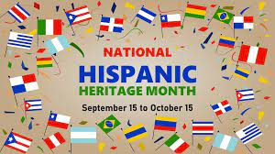
Sunday | Monday | Tuesday | Wednesday | Thursday | Friday | Saturday
 |  |  |  |  | 1 | 2
3 | 4 | 5 | 6 | 7 | 8 | 9
 | No School –  Labor Day  School Holiday | Parent Lunches  Kindergarten/ 1st, 3^{rd,} and 4th Grade |  | Parent Lunches  2nd grade and 5th grade
10 | 11 | 12 | 13 | 14 | 15 | 16
 | Grandparents Luncheon  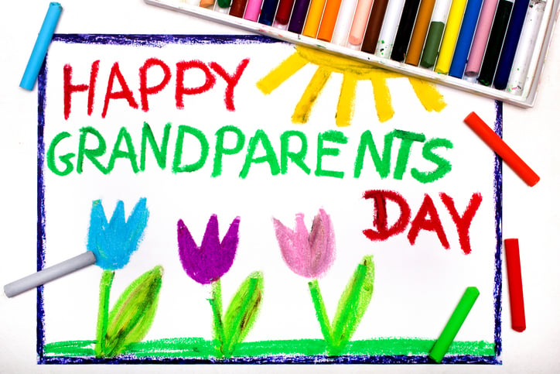 | Parent Lunches  Kindergarten/ 1st, 3^{rd,} and 4th Grade |  | Parent Lunches  2nd grade and 5th grade  OPEN HOUSE  4:30- 5:30 | Represent México  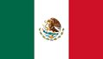  Wear Red, White & Green!  Early Dismissal @ 12:10 pm | 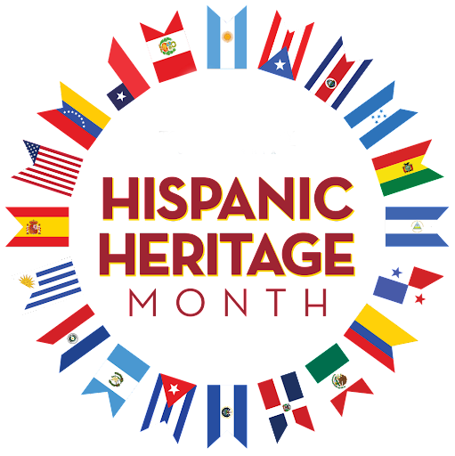
17 | 18 | 19 | 20 | 21 | 22 | 23
 | Represent Guatemala  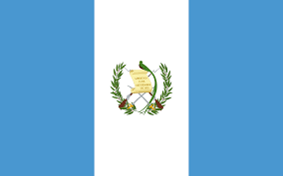  Wear Blue & White Shirt! | Represent Cuba  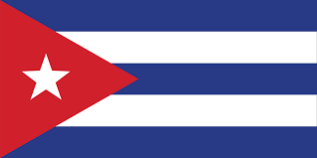  Wear Red, White & Blue Shirt!  Parent Lunches  Kindergarten/ 1st, 3^{rd,} and 4th Grade | Represent Honduras  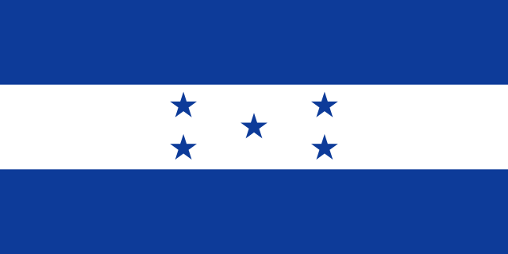  Wear Blue & White Shirt! | Represent Chile    Wear Red, White & Blue Shirt  Parent Lunches  2nd grade and 5th grade | Represent Panamá  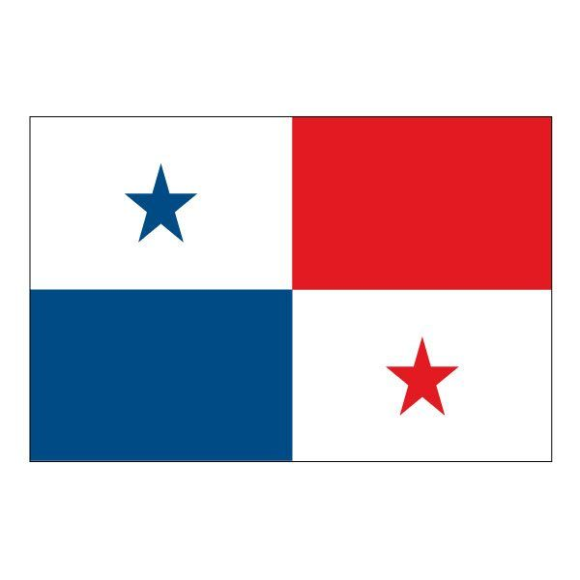  Wear Red, White & Blue Shirt!
24 | 25 | 26 | 27 | 28 | 29 | 30
 | Represent El Salvador  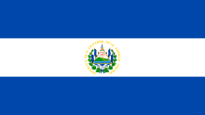  Wear Blue & White Shirt! | Represent Colombia  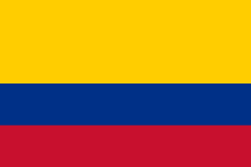  Wear Red, Yellow & Blue Shirt!  Parent Lunches  Kindergarten/ 1st, 3^{rd,} and 4th Grade | Represent Spain  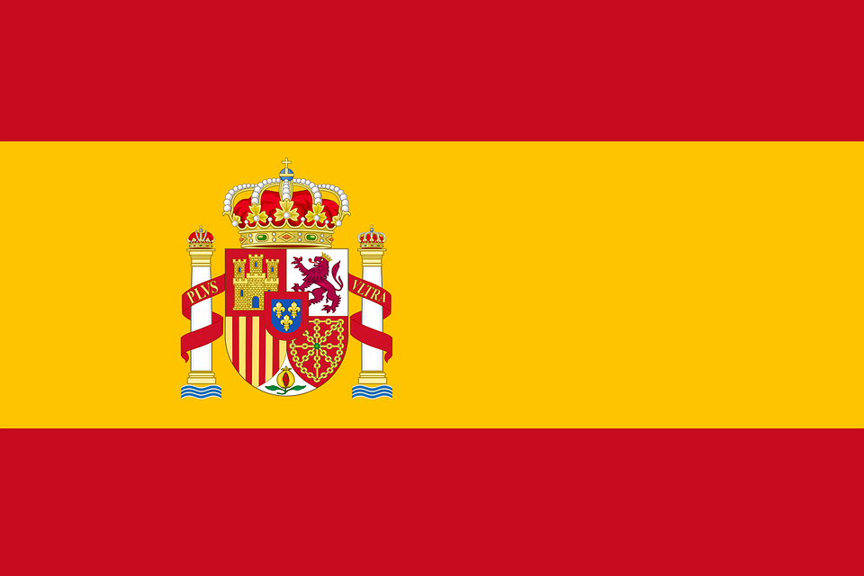  Wear Yellow and Red Shirt!  Hispanic Heritage Program  4:30pm | Represent Venezuela  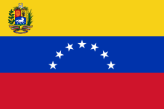  Wear Red, Yellow & Blue Shirt!  Parent Lunches  2nd grade and 5th grade | No School

